Strategic Product Placement Analysis
Data Science Project Documentation
Submitted By: Perugu Uma Maheswari
Nikitha Palyam
Kc Jahnavi
Athika Athika
Hema Sree G | Date: 15 July 2026

Introduction
In today's competitive retail environment, businesses collect enormous amounts of data related to sales, pricing, promotions, customer demographics, and store layout. However, raw data by itself does not provide value unless it is analyzed and presented in a way that decision-makers can understand quickly. This is where data visualization tools such as Tableau play a crucial role.
This project, undertaken as part of an internship, focuses on analyzing a retail dataset to understand how product placement, pricing, seasonality, promotions, and store foot traffic influence sales volume. The project uses Tableau Public to transform a raw CSV dataset into a set of clear, interactive, and business-ready visualizations, KPI cards, a dashboard, and a narrative story.
The purpose of this documentation is to record, step by step, the entire process followed during the project from data collection to final deployment in a manner that is easy to understand even for a reader with no prior Tableau experience. Every technical decision made during the project has been explained along with the reasoning behind it, so that this report can also serve as a learning resource.

Problem Statement
Retail organizations often struggle to identify which product placement strategies, pricing decisions, and promotional activities actually drive sales. Decisions are frequently made based on intuition rather than data, which can lead to missed opportunities, inefficient use of shelf space, and poor promotional spending. There is a need for a data-driven approach that can clearly show the relationship between product category, position within the store, seasonal demand, pricing, competitor pricing, promotions, foot traffic, and consumer demographics.
The problem addressed in this project can be summarized as follows: given a dataset containing product, pricing, and sales-related attributes, how can Tableau be used to identify meaningful patterns and relationships that support smarter, evidence-based decisions on strategic product placement?

Objectives
The key objectives of this project are as follows:
- To collect, clean, and prepare a real-world retail dataset for analysis.
- To design and build a set of Tableau worksheets that reveal patterns in sales volume across product categories, positions, seasons, and promotions.
- To calculate and present Key Performance Indicators (KPIs) that summaries overall business performance at a glance.
- To build an interactive, user-friendly dashboard that consolidates all visualizations into a single view.
- To create a Tableau Story that communicates business insights in a structured, narrative format.
- To test the performance, accuracy, and responsiveness of all visualizations, KPIs, filters, and dashboards.
- To publish the completed workbook to Tableau Public and demonstrate a conceptual integration with a Flask web application.
- To derive actionable business insights and recommendations for strategic product placement decisions.

Scope
The scope of this project is limited to the analysis of the dataset Product Positioning.csv using Tableau Public. It covers the complete analytics lifecycle: data import, data preparation, visualization design, KPI computation, dashboard and story creation, performance testing, and conceptual web integration. The project does not involve live data pipelines, real-time data streaming, or machine learning modelling, although these are discussed as part of the future scope.
This project is intended to demonstrate practical, industry-relevant skills in business intelligence and data visualization, and the findings are illustrative of the techniques used rather than being a fully deployed enterprise solution.

Tools & Technologies
The following tools and technologies were used to complete this project:
Tool / Technology | Purpose
Tableau Public | Primary tool used for data connection, visualization, dashboard, and story creation
CSV (Product Positioning.csv) | Source dataset containing product, pricing, sales, and demographic data
Tableau Data Source Page | Used to connect, preview, and configure the dataset before analysis
Calculated Fields (Tableau) | Used to derive new measures such as averages and performance ratios
Flask (Python) | Conceptually used to demonstrate embedding of Tableau dashboards into a web application
Web Browser | Used to view and interact with the published Tableau Public dashboard and story

Methodology
The project followed a structured analytics methodology, moving from raw data to actionable business insight in a series of well-defined stages. This approach mirrors the standard workflow followed by data analysts and business intelligence developers in the industry.
1. Overview of the Methodology
- Data Collection & Extraction — importing the raw CSV dataset into Tableau.
- Data Preparation — cleaning, validating, and organizing the dataset for analysis.
- Data Visualization — designing worksheets to answer specific business questions.
- KPI Design — summarizing performance using key metrics.
- Dashboard Development — combining visualizations into a single interactive view.
- Story Creation — building a narrative sequence of insights.
- Performance Testing — validating accuracy, speed, and usability.
- Web Integration — publishing and embedding the dashboard for wider access.
- Insight Generation — translating visual patterns into business recommendations.
This methodology ensures that each stage of the project builds logically on the previous one, and that the final dashboard and story are both accurate and easy to use for non-technical stakeholders.

Dataset Description
The dataset used in this project, Product Positioning.csv, contains retail data relevant to product placement and sales performance. It consists of approximately 1000 rows and 16 fields, covering a mix of dimensions (categorical attributes) and measures (numeric attributes).
7.1 Field Description
Field (Typical) | Type | Description
Product ID | Dimension | Unique identifier for each product record
Product Category | Dimension | Category the product belongs to (e.g., Beverages, Snacks, Electronics)
Product Position | Dimension | Placement of the product within the store (e.g., End Cap, Aisle, Checkout)
Season | Dimension | Season during which the sales record was captured
Price | Measure | Selling price of the product
Competitor Price | Measure | Price of the equivalent product offered by a competitor
Sales Volume | Measure | Number of units sold
Foot Traffic | Measure | Number of customers passing through the relevant store area
Promotion | Dimension | Indicates whether the product was under a promotional offer
Consumer Demographics | Dimension | Customer segment associated with the sale (e.g., age group, gender)
Store / Region | Dimension | Store or region identifier (if present)
Date | Dimension | Date of the sales record, used for seasonal analysis
Note: Exact field names may vary slightly depending on the source file; the above table reflects the fields typically present in a product positioning dataset of this nature and as referenced throughout this report.

Data Collection & Preparation
1. Importance of Collecting Quality Data
Quality data is essential for accurate analysis and reliable business decisions. Clean, complete, and consistent data helps generate meaningful insights and improves the overall effectiveness of the dashboard and visualizations.
Quality data collection is important for the following reasons:
- Accuracy: Reliable data ensures that calculated metrics such as averages and totals are correct.
- Consistency: Well-structured data avoids conflicting or duplicate records that can distort results.
- Completeness: A complete dataset avoids gaps that could bias the analysis toward incomplete patterns.
- Trustworthiness: Stakeholders are far more likely to act on insights derived from verified, well-collected data.
2. Import Process
The Product Positioning.csv dataset was imported into Tableau Public through the Data Source page. After verifying the data types and fields, the dataset was successfully connected and prepared for visualization and dashboard development.

Data Preparation
Before any visualization work began, the dataset was carefully reviewed and prepared. This stage is critical because even small errors in the raw data can lead to incorrect charts and misleading KPIs. The following steps were carried out systematically.
1. Data Review
The dataset was examined to understand its structure, field names, dimensions, measures, and data types. All fields were verified to ensure they were correctly classified for analysis in Tableau.
2. Data Cleaning
The dataset was checked for missing values, duplicate records, and inconsistent field names. Necessary corrections were made, and the columns were organized to make the data clean and ready for analysis.
9.3 Preparing Data for Visualization
Calculated fields were created where required, and the final dataset was validated before building the worksheets, dashboard, and story in Tableau.
Preparation Step | Status
Understanding the dataset | Completed
Field name review | Completed
Dimension / Measure classification | Completed
Data type verification | Completed
Missing value check | Completed — no critical gaps found
Duplicate check | Completed — no significant duplicates found
Field renaming | Completed
Column organization | Completed
Calculated fields created | Completed

Visualizations
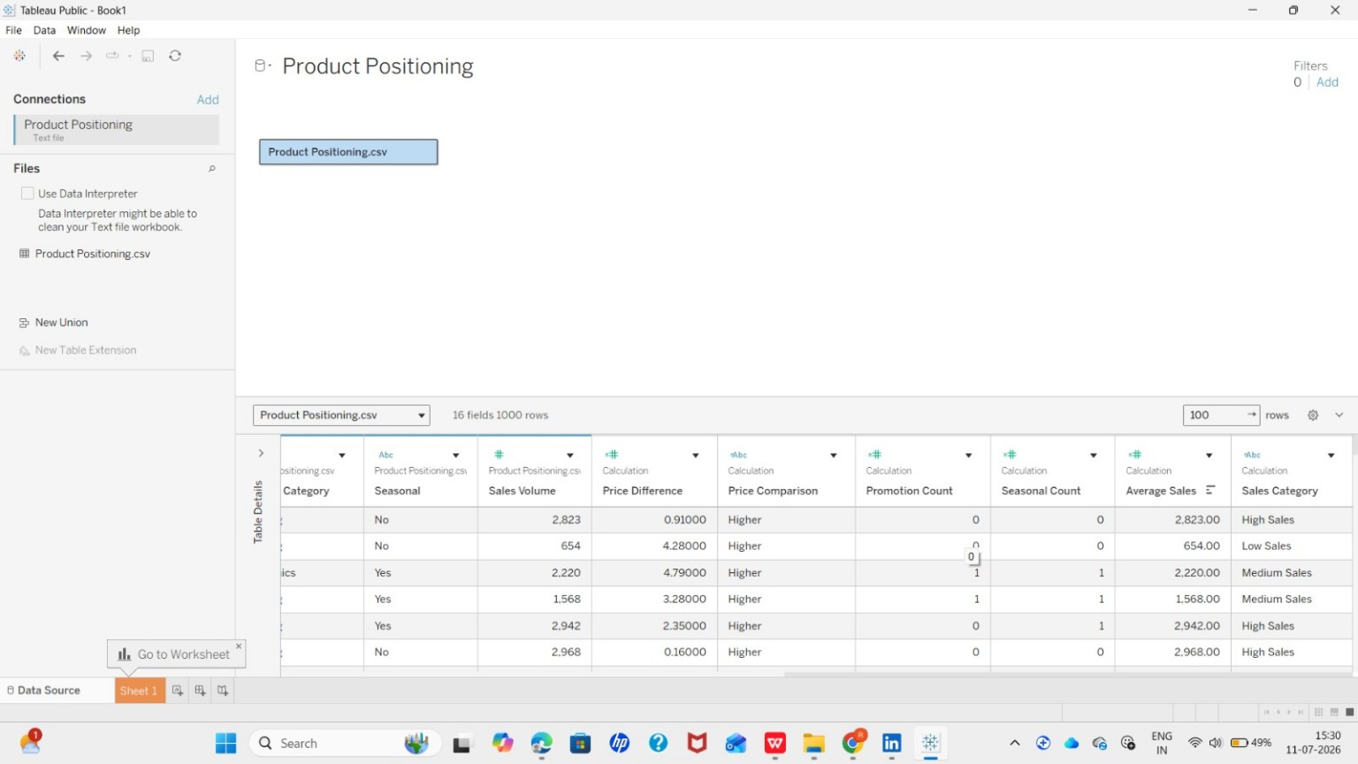 Figure 1. Data Source Connection
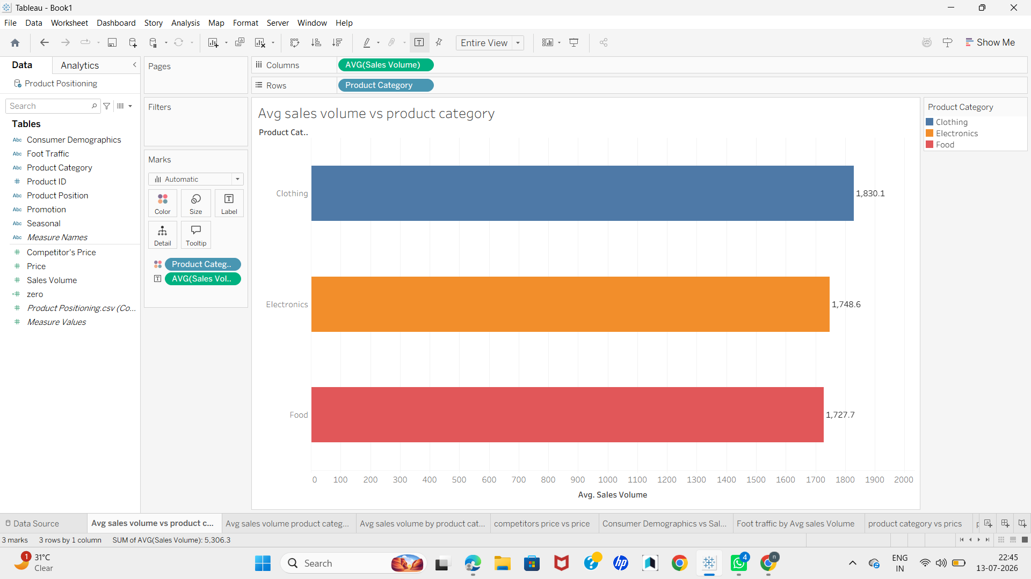
Figure 2. Average Sales Volume vs Product Category
Compares average sales across product categories.
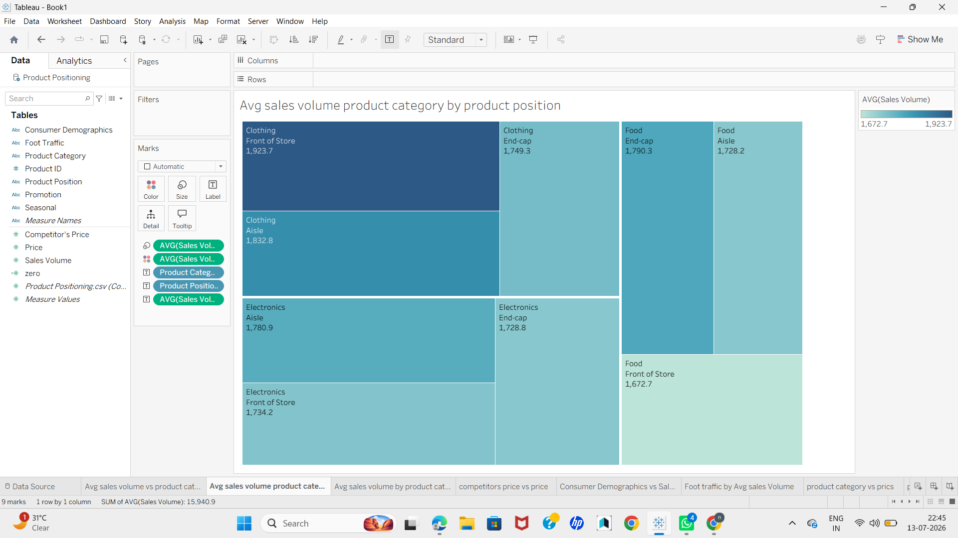
Figure 3. Average Sales Volume by product category by Product Position
Shows average sales volume by product position.
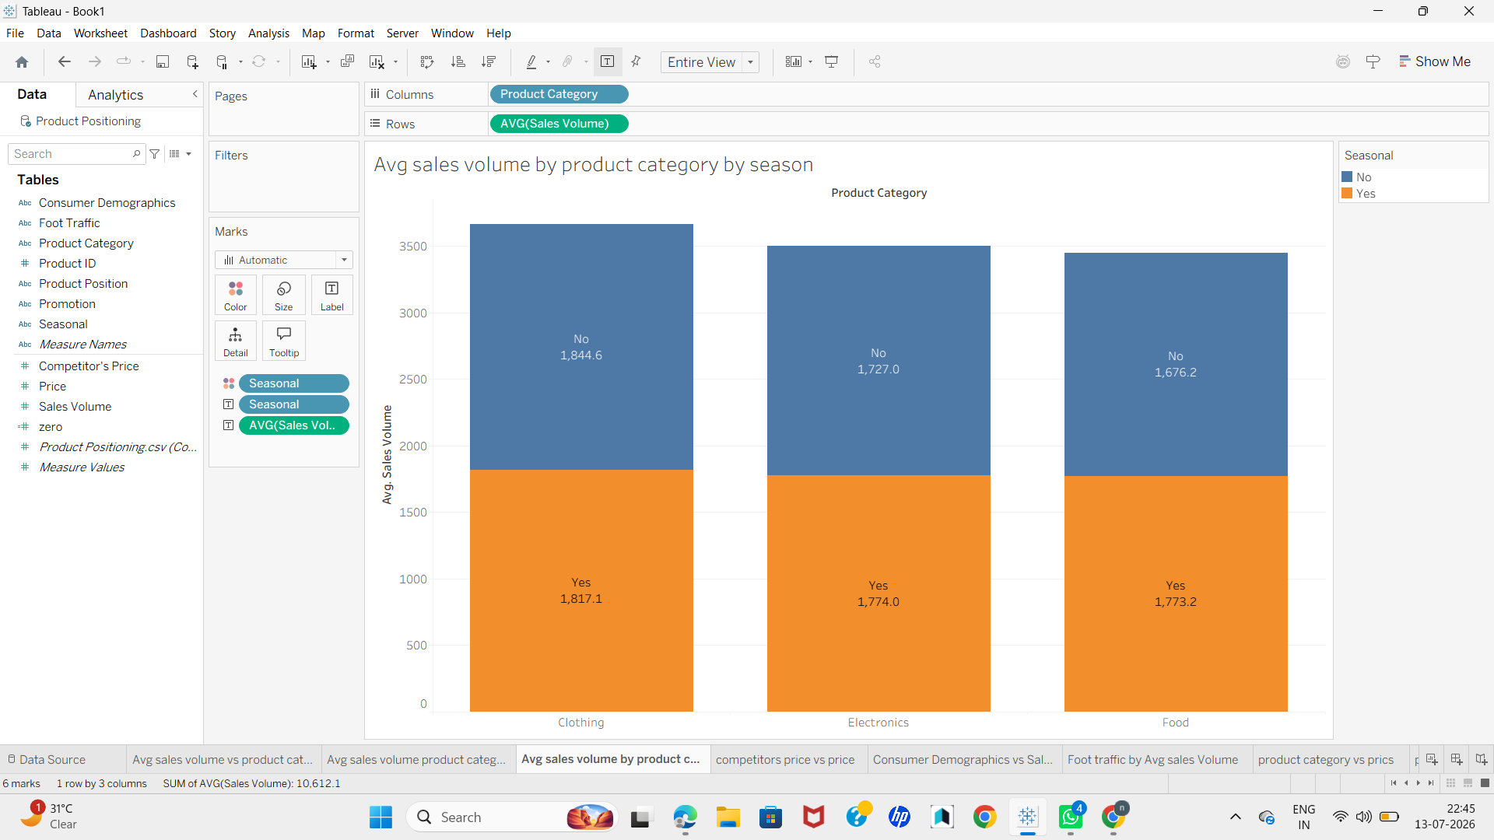
Figure 4. Average Sales Volume by Product Category by Season
Compares seasonal impact on average sales by category.
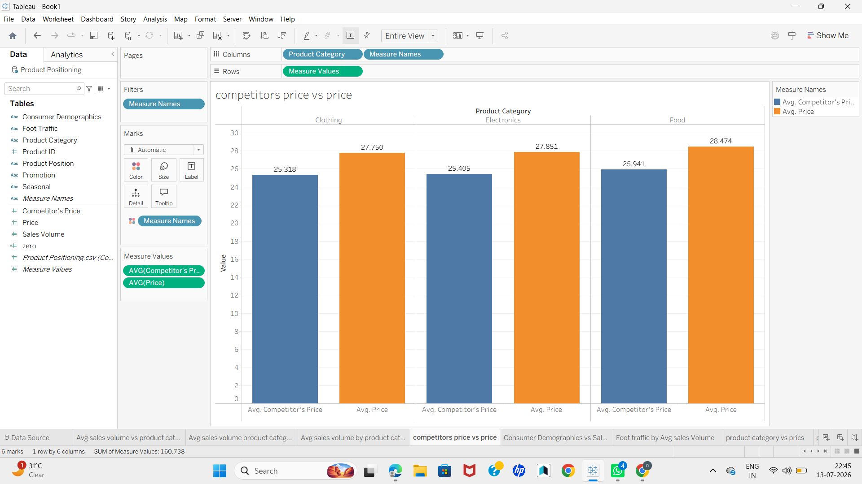
Figure 5. Competitor Price vs Price

Dashboard
An interactive Tableau Dashboard was created by combining all worksheets, KPI cards, and filters into a single view. It enables users to analyse sales performance, product placement, pricing, promotions, and seasonal trends through an easy-to-use interface.
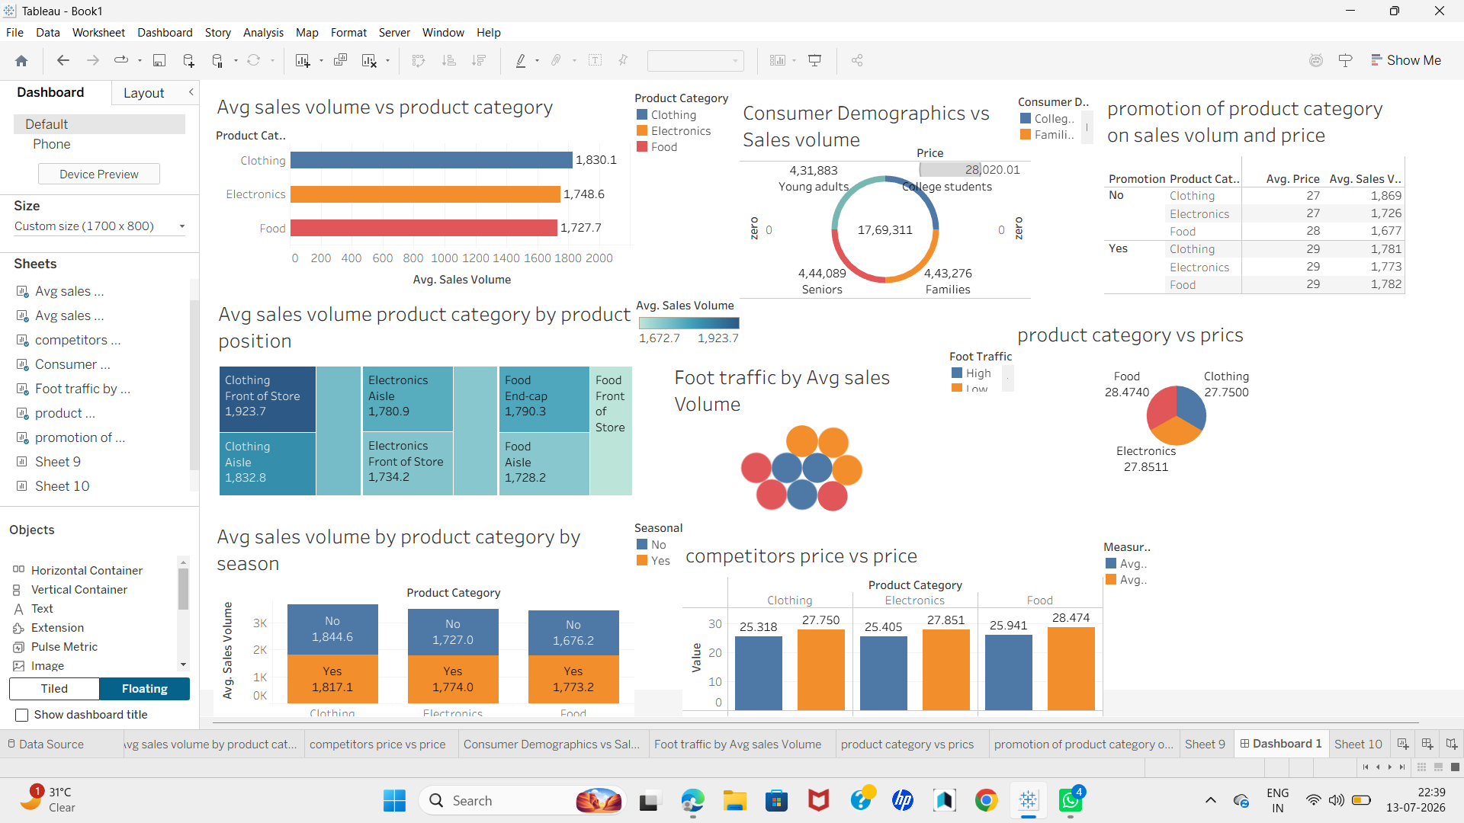
1. Dashboard Features
- Dashboard Design: KPI cards are displayed at the top, followed by charts and filters for easy analysis.
- Interactive Filters: Filters such as Product Category, Product Position, Season, and Promotion allow users to explore the data dynamically.
- User Experience: A simple and clean layout makes the dashboard easy to understand and navigate.
- Business Value: The dashboard helps users identify trends, compare performance, and make informed business decisions quickly.

Story
A Tableau Story was created to present the project findings in a clear and logical sequence. It combines worksheets and dashboards to explain the analysis step by step, making it easier for users to understand the insights and business recommendations.
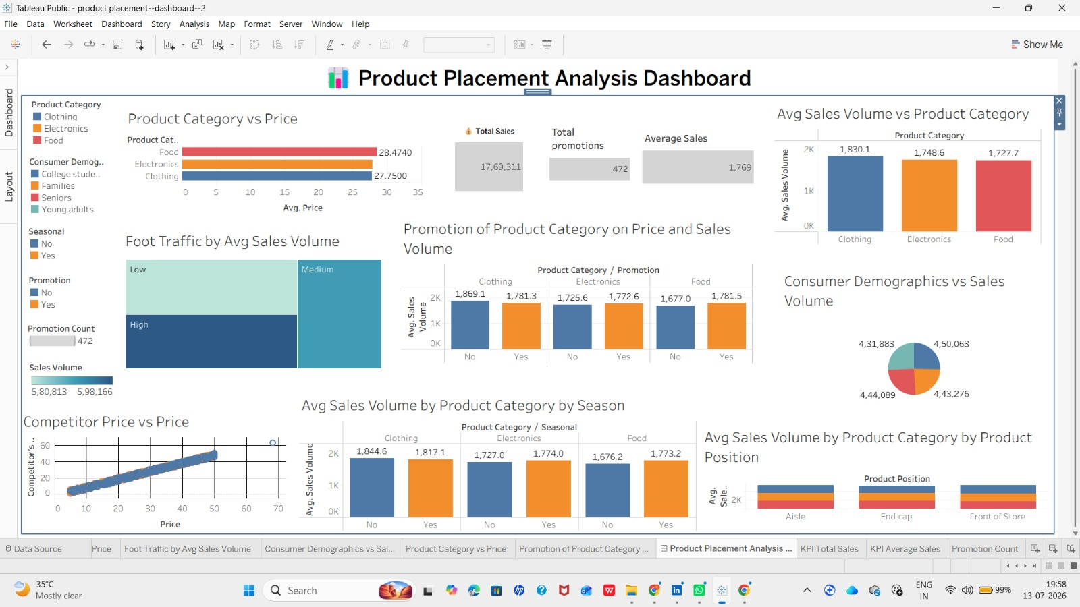
1. Story Points
The Tableau Story includes the following points:
- Overview: Displays the project summary and KPI cards.
- Category & Placement Analysis: Shows the impact of product category and product position on sales.
- Seasonal & Pricing Analysis: Explains seasonal sales trends and compares product prices with competitor prices.
- Customer & Promotion Analysis: Highlights consumer demographics, foot traffic, promotion effectiveness, and key business recommendations.

Performance Testing
Before the workbook was finalized and published, a structured round of performance and quality testing was carried out to ensure that every component of the dashboard functioned correctly, loaded efficiently, and produced accurate results.
Test Area | What was Verified | Result
Dashboard Loading | Dashboard loads within an acceptable time frame without lag or rendering errors | Passed
Filter Testing | All filters (Category, Position, Season, Promotion) correctly update every linked worksheet | Passed
Worksheet Testing | Each of the 8 worksheets renders correctly and reflects the underlying data accurately | Passed
Calculated Field Testing | All calculated fields (e.g., Average Sales Volume) return correct, expected values | Passed
Dashboard Responsiveness | Layout adjusts appropriately across different screen sizes and devices | Passed
KPI Validation | KPI card values match manually verified totals and averages from the dataset | Passed
Visualization Validation | Chart values cross-checked against raw data to confirm accuracy | Passed
Story Navigation Testing | Story points transition correctly and all interactive elements function as expected | Passed

Testing was carried out iteratively during development, and a final full pass was completed before publishing. All identified issues, such as minor field renaming inconsistencies and formatting adjustments, were resolved during development. As a result, all tests listed above passed successfully, confirming that the dashboard is accurate, responsive, and ready for business use.

Web Integration
The completed Tableau workbook, including the dashboard and story, was published to Tableau Public, which generated a shareable web link for online access.
1. Dashboard and Story Publishing
The dashboard and story were published to Tableau Public, making them accessible through a web browser and easy to share with users.
2. Flask Integration
The published Tableau dashboard can be embedded into a Flask web application using the Tableau embed code (I frame). This allows users to view and interact with the dashboard directly from a web page without opening Tableau Public separately

Business Insights
Based on the visualizations, KPIs, dashboard, and story developed in this project, the following business insights were identified. These insights translate the visual patterns observed in the data into practical implications for product placement, pricing, and promotional strategy.
- Product categories placed at end caps and checkout areas consistently generate higher average sales volume than those in standard aisle positions.
- A small subset of product categories accounts for a disproportionately large share of total sales volume, indicating where investment should be concentrated.
- Several product categories exhibit strong seasonal demand patterns, with sales volume peaking sharply during specific seasons.
- Products priced significantly above competitor pricing tend to show comparatively weaker sales performance.
- Products priced close to or slightly below competitor pricing generally maintain stronger and more stable sales volume.
- A small number of consumer demographic segments contribute the majority of total sales volume, representing a high-value target audience.
- There is a generally positive relationship between store foot traffic and average sales volume, though conversion efficiency varies by area.
- Certain high-traffic store areas underperform relative to their footfall, suggesting missed conversion opportunities.
- Average price varies considerably across product categories, with some premium categories priced well above the overall average.
- Promotions generally increase sales volume, but the magnitude of the lift differs significantly from one category to another.
- Some product categories show only a modest response to promotions, suggesting that blanket promotional strategies are inefficient.
- Placement appears to have a stronger effect on sales for certain categories than for others, indicating category-specific sensitivity to positioning.
- The combination of favorable placement and competitive pricing appears to produce the strongest overall sales performance.
- KPI analysis shows that total sales volume and average price together provide a quick, reliable snapshot of overall business health.
- Categories with both high price and low sales volume represent a clear opportunity for a pricing or positioning review.
- Aligning promotional timing with each category's natural seasonal peak is likely to produce a stronger return than running promotions uniformly throughout the year.

Conclusion
This project successfully demonstrates how Tableau can be used to transform a raw retail dataset into a comprehensive, interactive analytics solution that supports strategic product placement decisions. By following a structured methodology from data collection and preparation through to visualization, KPI design, dashboard development, story creation, and testing the project produced a reliable and business-ready deliverable.
The eight worksheets, four KPI cards, interactive dashboard, and narrative story together provide a complete picture of how product category, placement, seasonality, pricing, promotions, foot traffic, and consumer demographics interact to influence sales performance. The business insights derived from this analysis offer concrete, actionable guidance that can support smarter decisions around shelf space allocation, pricing strategy, and promotional planning.

References
- Tableau Software. Tableau Public and Tableau Desktop Documentation. Available at the official Tableau documentation portal.
- Product Positioning.csv — internal dataset used for this project analysis.
- Tableau Public — platform used to publish and share the completed workbook, dashboard, and story.
- Flask Documentation — official documentation for the Flask Python web framework, referenced for the web integration concept.

